Student Name : Prajalkumar Ramjiyani

Student Id : 12045947

Course name : Master of IT

Course Code : CC54

Tutor: Watagodakumbura, Chandana Dharma

Outputs:

Test Result 1:

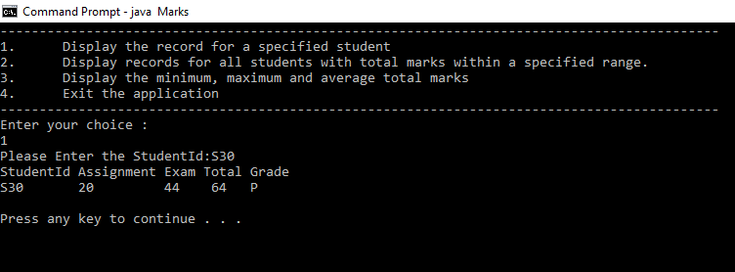

Test Result 2:

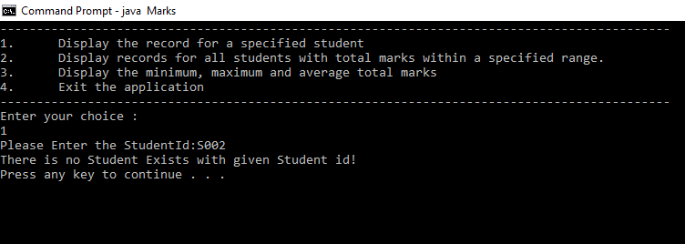

Test Result 3:

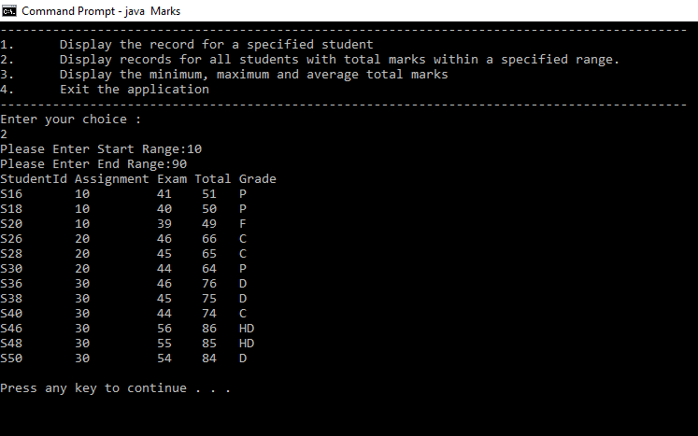

Test Result 4:

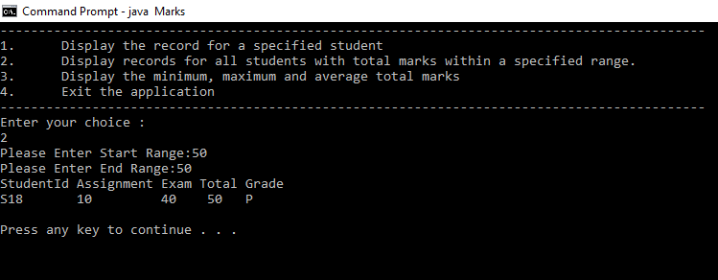

Test Result 5:

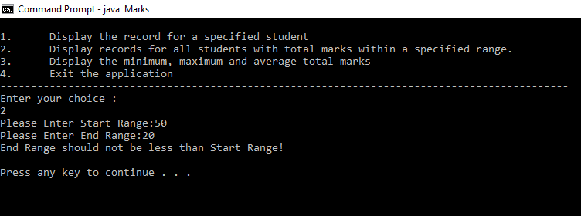

Test Result 6:

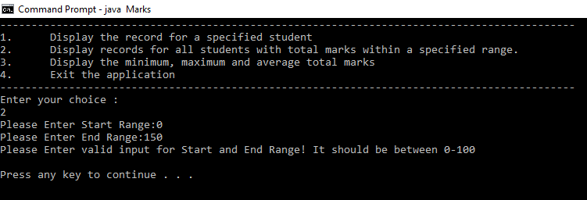

Test Result 7:

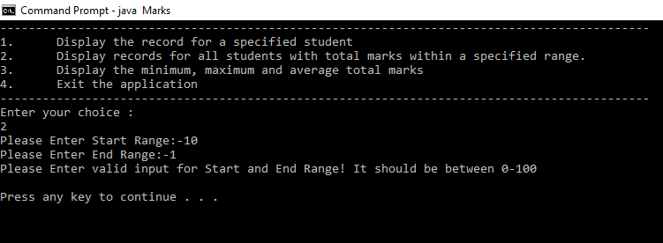

Test Result 8:

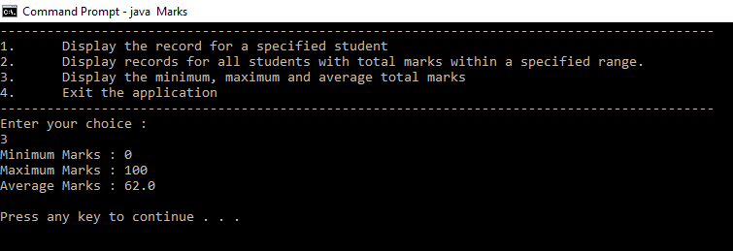

Test Result 9:

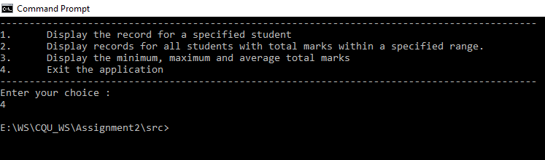

Test Result 10:

